Forensic Verification of Handwritten Documents using Secure Multi Party Computation

R Raja Subramanian
Dept of Computer Science and Engineering
Kalasalingam Academy of Research and Education
Krishnankoil, Virudhunagar, Tamil Nadu, India
rajasubramanian.r@klu.ac.in
Chunduri Sandya Niharika
Dept of Computer Science and Engineering
Kalasalingam Academy of Research and Education
Krishnankoil, Virudhunagar, Tamil Nadu, India
sandyachunduri05@gmail.com
Harini Mohan
Dept of Computer Science and Engineering
Kalasalingam Academy of Research and Education
Krishnankoil, Virudhunagar, Tamil Nadu, India
harinimohan19@gmail.com

Ketepalli Poojita Lakshmi Syamala
Dept of Computer Science and Engineering
Kalasalingam Academy of Research and Education
Krishnankoil, Virudhunagar, Tamil Nadu, India
poojitakkr@gmail.com
Ede Venkatesh
Dept of Computer Science and Engineering
Kalasalingam Academy of Research and Education
Krishnankoil, Virudhunagar, Tamil Nadu, India
Venkateshede3@gmail.com

Abstract— The recent advance in the use of image processing techniques has benefitted many areas including forensic and digital verification in cybercrime detection. Image processing techniques are used for producing digital evidence in criminal activities including counterfeiting of currency notes, cheques, fake government documents, wills, official reports and certificates. In this article, we find the solution to help document verifier or examiner to find out and differentiate a fake document from the original document. However, we need to secure all the documents that are used for verification to maintain data security. Therefore, we use Secure Multi-Party Computation to preserve the documents securely. The expected solution focusses on image processing tools for verification of computer manipulated documents and capable of detecting altered written documents preserving the documents integrity all through the process. The objective of this article is to build an ImageNet model with an accuracy of >97%, and to keep the false negative rate less than 5%. The accuracies achieved by ResNet50 and VGGNet16 using SMPC are 97.62% and 93.88% respectively in verifying the unauthorized document given by the author.
Keywords— Image Processing, Fake document, Handwritten documents, Forensic Verification, Secure Multi-Party Computation.

Introduction
In recent times, cybercrime activities have been increased more than 50 percent in every country. The state of art technologies gradually advanced to detect the cybercrimes digitally using image processing in Artificial Intelligence. As part of this, forensic verification of documents plays a crucial role to overcome cybercrime activities. In this paper, we discuss about verification of unauthorized handwritten documents. The input taken for document verification can be any object that contains handwritten markings and symbols which convey some meaning or information.
According to Indian Evidence Act and Indian Penal Code, “Document denotes any matter expressed or described upon any substance by means of letters, figures or marks or by more than one of those means, intended to be used, or which may be used, as evidence of the matter”. If the authenticity of the document is challenged or the source of origin is doubtful then the document is known as fabricated document or questioned document. Questioned documents can be in the form of letters, cheques, contracts, wills, historical documents and more [1]. Cases like forgery, counterfeiting, suicide notes, homicide can be detected by using fake document verification technique.
The objective of this article is to verify the document using handwriting of the author. Handwriting can be used as an important biometric which is unique for every individual. Though the handwriting identification of a questioned document is recurrent problem, the author inference is essential. This involves pattern recognition in forensic science that examines features of handwritten texts in the questioned document and verifies the author inference. Even there are traditional document verification techniques and deep learning models, we mainly focus on ImageNet models that enhance the accuracy through image processing. In addition, we secure the documents received for training and testing, as the integrity of the document is questioned and therefore the cybercrime activities happen to steal data. Hence, we secure the data obtained using security algorithms like Secure Multi-Party Computation (SMPC). Therefore, we obtain the genuine documents or authenticated documents of the author and secure the data and train them using ImageNet model. Then we get the questioned document for testing. The model predicts the tested document as fake or genuine. Herewith, we understand the importance of document verification and security. Therefore, we tend to improve the accuracy of the document in verifying its originality.
This paper is organized as follows: Section II explains the literature survey of the research. Section III represents the dataset used for the research. Section IV represents workflow of the research work. Section V represents pre-processing and augmentation of the data. Section VI represents implementation, Section VII depicts the results, followed by conclusion, future work of the research and references.

Literature Survey
Forensic Verification of handwritten documents includes various similar studies as the verification of the documents is based on the handwriting of the author. Even though the verification is text-independent, the analysis of studies includes writer identification using handwriting on words, signature verification and evaluation on handwritten documents. Single sample writers – “Document Filter” and their impacts on writer identification, this paper proposes a Document filter protocol used as a preprocessing technique [2]. Despite the document filter protocol, the paper gives a clear understanding of categorizing the task into writer identification, writer identification and writer monitoring. This paper would give the basic understanding of handwritten databases on which our task can be performed. A comprehensive study of handwritten document benchmarks: structure, usage and evaluation, this paper provides the details of various available databases for each domain [3]. The survey, usage and basic of the benchmark databases are given. From this paper, we can understand the handwriting can be considered as some unique patterns followed by humans in their unique style. Hence, the handwriting of each author can be recognized using Pattern recognition techniques. Interpol Review of questioned documents 2016 – 2019, this paper reviews the forensic literature over the years 2016 to 2019. This paper provides a lot of forensic methods to verify the documents through various techniques including spectroscopy methods, diffraction methods, Ink and paper analysis, dating, security, handwriting/signature and more [4]. We also get to know about forensic intelligence. Writer verification based on a single handwriting word samples, this paper presents a new approach for writer authentication based on analysis of two words [5]. The difference between signature authentication and writer recognition can be understood clearly for efficient understanding of basics of our works. Handwritten Text Recognition using Deep learning with TensorFlow, paper gives a view on character recognition using Neural Networks for classifying the handwriting in emerging technologies of computer vision [6]. The proposed approach involves Convolution Neural Networks using TensorFlow in recognizing the handwritten text.
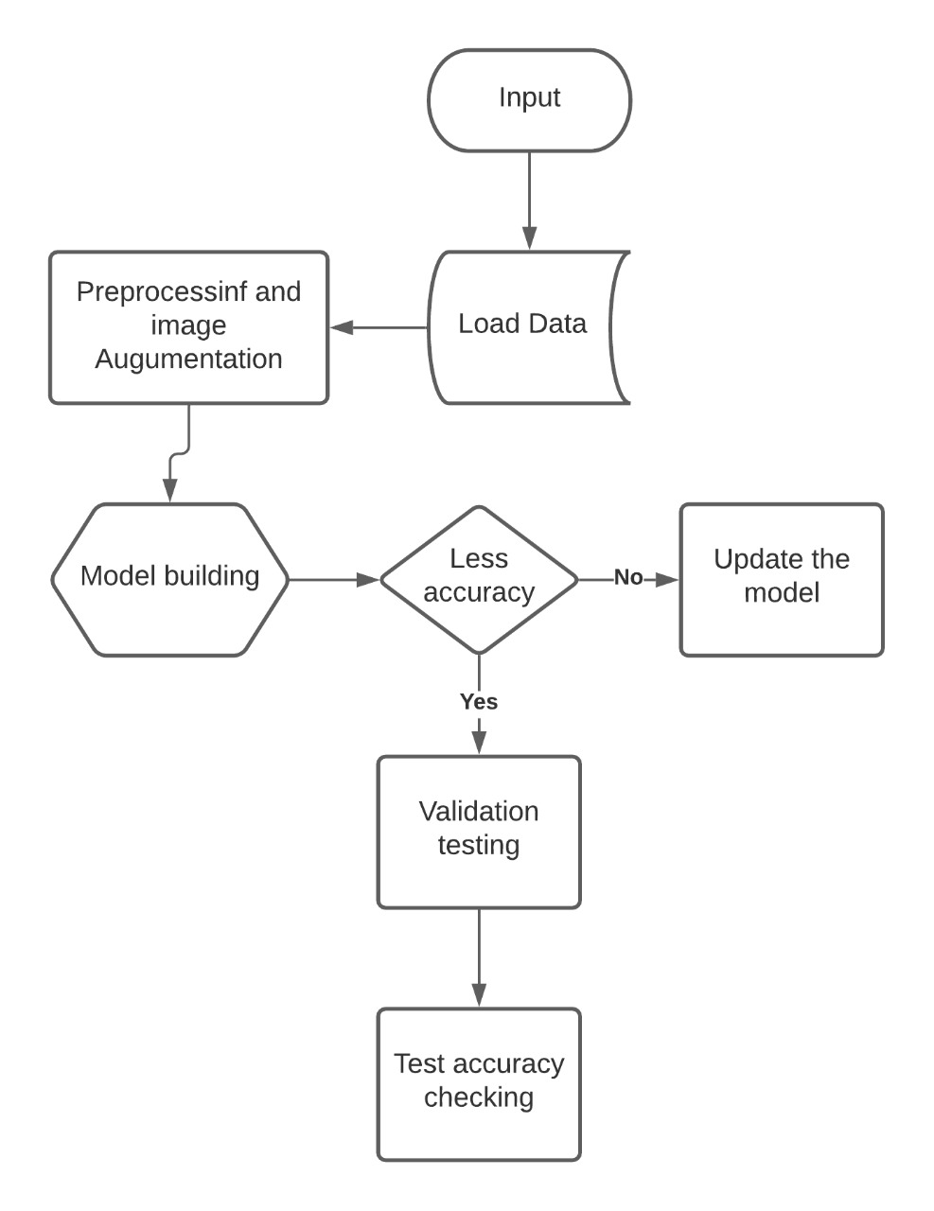

The forensic verification of documents can also be done using Texture Descriptors like Local Binary Patterns (LBP), Local Ternary Patterns (LTP) and Local Phase Quantization (LPQ) which can detect the features of the input image and can capture the similar textures or pattern of image data [7]. The efficient outcomes for Pattern Recognition problems like Handwriting verification, face identification can be achieved by Machine learning algorithms [8,9,10] and Convolutional Neural Network (CNN) models [11,12,13]. For identifying the specific feature more accurately, we have genetic algorithms and optimization algorithms like Particle Swarm Optimization, Genetic algorithm that can find our best possible handwriting patterns of an author from a group of handwriting documents [14,15,16,17].

Dataset
We consider IAM Handwriting Database for this research. IAM is an On-Line Handwriting database which contains forms of handwritten English text. The IAM database is used for many studies. In this research, we consider the handwriting image of each author as a handwritten document. The IAM Handwriting dataset contains scanned handwriting images of 657 authors [18]. Here, we modify the database such that each folder name is given by its author name like a01, a02, b06, c03, and more. The sample handwriting images are depicted in Fig.1. The main aim of our work is to find out whether the given handwritten document belongs to respective author defining it as genuine or fake. We categorize the images as genuine and fake and process this as input for the model of fake verification of documents. For example, the a01 author handwritten images are categorized as genuine and remaining author images as fake. We modify the data to in this way to identify the authorized author of the document efficiently by using handwriting of each author as key component. Some of the handwritten image documents are depicted below:
Fig. 1. Sample Handwritting images from the dataset.

Workflow
The workflow of the Forensic verification process is depicted in Fig.2. First, we load the data extracted from IAM Handwriting Database followed by preprocessing the input data using Secure Multi-Party Computation and image augmentation of data like horizontal flip, vertical flip and more. Next, we build CNN model using ImageNet weights. By obtained accuracy, we can update the model or check for validation or test the model with unknown image data or document to get prediction accuracy.
Fig. 2. Workflow of Forensic Verification

Preprocessing and Augmentation of data
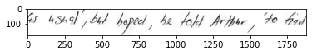
The initial input data given to the forensic verification must be secured to avoid further fabricating of data. The documents given are considered as data in securing the documents. Therefore, we use security algorithms to secure the data from unauthorized persons. These maintain the privacy and efficiency in maintaining the integrity of the data. There are many cryptographic methods to assure the security and integrity of the data. In our process, we need to assure the privacy of each author who provides his documents. Hence, we prefer Secure Multi-Party Computation (SMPC) for preserving the private data of each author and to process the data with no changes until the end of the workflow.

Secured Multi-Party Computation ensures the data meets the desired accuracy and precision without any changes in data. SMPC computes the data of many users at a time, and the integrity of data provided by each user is maintained. All the users have their private data need to be secured. SMPC computes a function to secure every user’s data. The user knows the values of a part of function of his respective data. The other users’ data or value of its function is not revealed. Hence, with the help of the value, he can find out his function and clear the exponential function to reveal his data. As the value of the function is split, the unauthorized person is not able to reveal the function. Therefore, SMPC provides privacy to his user, saves the integrity of data [19,20,21]. This secures the private data of each author and thus Secure Multi-Party Computation can help in securing the documents of all the authors.

In our problem, the input data undergoes Secure Multi-Party Computation (SMPC). The initial data for training the model undergoes multi party computation and the data of all the authors are split into many parts and loaded into model to avoid fabrication or duplication of important documents submitted by authors. Then the images of data or documents are augmented using various flips like horizontal and vertical flips and more. The images are rotated in various angles to sharpen the detection skill of the model.

The handwriting documents of respected author are considered as genuine and the other documents are considered as fake. This applies for each of the document in dataset. The sample images of handwritten documents of an author are depicted as Genuine and Fake in Fig 3 & 4 respectively. In real-time, the documents collected from the author are trained and considered as genuine. The document for testing is analyzed and detected either genuine or fake based on pattern recognition through CNN models. The testing documents also undergoes the computation process and augmented, then provided for testing in model.
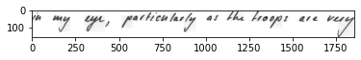
Fig. 3. Preprocessed Genuine Document

Fig. 4. Preprocessed Fake Document

Implementation using Cnn models
The Convolutional Neural Networks (CNN) is one of the most popular deep neural networks. CNN is efficient at pattern recognition and image processing [22]. The CNN can deal with image data and perform well in computer vision. It consists of multiple layers that include convolutional layer, non-linearity layer, pooling layer and fully connected layer. The elements of CNN are convolution, stride, padding, feature of CNN and convolutional formula. This makes CNN to be efficient. The non-linearity layer of CNN saturates the generated output such as sigmoid, tanh functions. In the image processing, we use pooling layers to reduce the complexity of further layers and in reducing the resolution. Pooling layers can be used with non-equal filters and strides to increase the efficiency of CNN model. One of the best pooling methods is max pooling. In fully connected layer of CNN, every node is connected to the previous and next layer. This increases the parameters of the CNN model, consequently increasing the complexity in computation. To overcome the complexity, we remove some nodes using dropout technique. Some initial and popular architecture models can be LeNet, AlexNet, ZFNet and more. Later on, many scientists gradually improved various CNN architectures that include Residual Neural Network (ResNet) and Visual Geometry Group Network (VGGNet). We use various optimizers that enhance the performance of the model. Some of the optimizers are Adam, Adagrad, stochastic gradient descent and more. In fake document verification, we use some of these optimizers in the following CNN models:

Residual Neural Networks (ResNet)
ResNet also known as Residual Neural Networks are mainly used to solve complex problems of deep neural networks. Many researchers started to use transfer learning i.e. pre-trained ResNet models and acquired good results compared to some other models. They have become the backbone for object detection and image classification. The main problems with deep neural networks are vanishing gradient problem, overfitting, higher training error, longer training time, harder optimization and degradation in accuracy. Some of the problems like overfitting can be solved by using dropout layer.
According to the article written by kaiming He, some of the major problems that occur at deep neural networks can be solved using deep residual networks. They follow skip connections and Identity mapping. The main advantage of skip connections is if a layer causes damage to the model, it will be skipped by regularization. The skip connections in Resnet model are depicted in Fig.5 [23]. This solves the vanishing gradient problem. Problems like harder optimization, convergence, degradation in accuracy, higher training error can be solved by ResNet.
Fig. 5. Skip Connections in ResNet
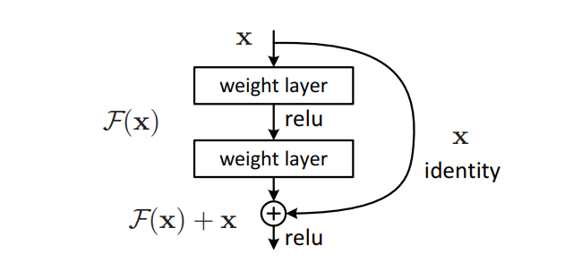

Visual Geometry Group Network (VGGNet)
VGG is a convolutional neural network model which have stack like architecture. There are 6 different VGG architectures. They are VGG11, VGG13, VGG16, VGG19 which have 11, 13, 16, 19 weight layers respectively. In this paper, we mainly present VGG16 model [24]. They have convolution layer of 3x3 filter with stride 1, use same padding and max pooling layer of 2x2 filter with stride 2. In VGG16, we don’t consider max pooling layer as a layer as it doesn’t contain trainable parameters. Its architecture looks similar stack as it contains the arrangement of convolution layers and max pooling layers throughout the architecture. The architecture of VGG16 is depicted in Fig. 6 as follows:

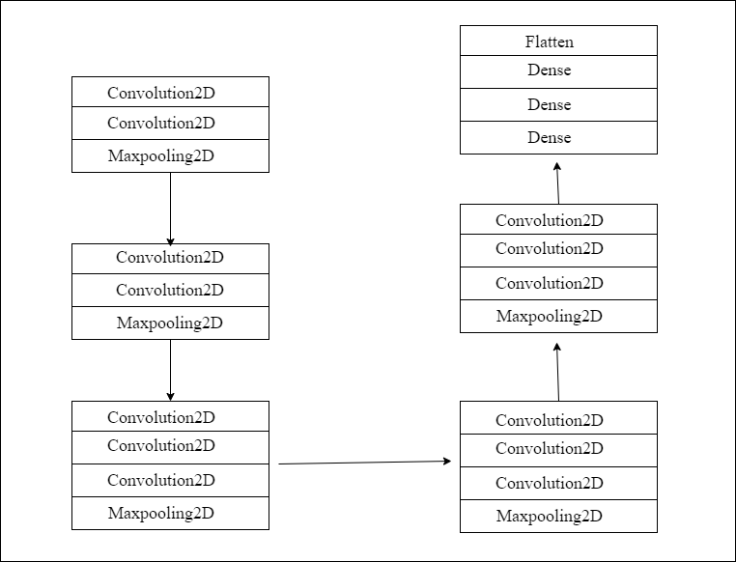
Fig. 6. VGG16 Architecture

Results
We have implemented CNN models using various optimizers by adding different dense and dropout layers. The best two models we presented in this paper are ResNet50 and VGG16 using transfer learning. The models contain Average pooling layer, dense layer and dropout layers. ReLu activation function is used and at the output layer SoftMax activation function is applied to classify our documents into Genuine or Fake. Even SoftMax layer is used for multiple classifications, in our research we use SoftMax layer as a binary classifier to classify the handwritten document as Genuine or Fake based on the probability 0 to 1. Therefore, the results of the models for 20 epochs are depicted in Table.I as follows:

- Accuracies of models for 20 epochs
Model | ResNet50 | VGG16
Training Accuracy | 96.19% | 89.96%
Testing Accuracy | 88.57% | 80.95%
Precision | 82.69% | 92.30%
Recall | 93.47% | 75.00%

The results of the ResNet50 model for 20 epochs along with the confusion matrix and test accuracy are depicted in Fig. 7 as follows:
Fig. 7. Confusion matrix of ResNet50 model with test accuracy
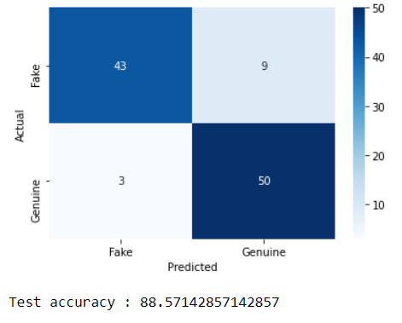
The results of the VGG16 model for 20 epochs along with the confusion matrix and test accuracy are depicted in Fig. 8 as follows:
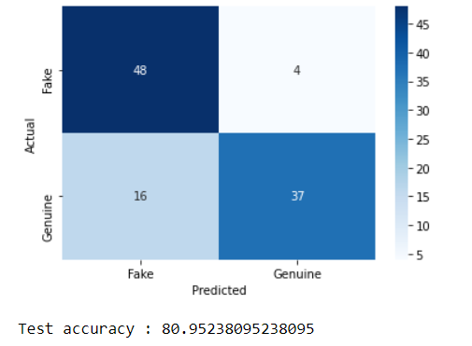
Fig. 8. Confusion matrix of VGG16 model with test accuracy
Further, we have increased the number of epochs of each model. The accuracies of each model gradually increased by increase in epochs. The accuracies of ResNet50 model and VGGNet16 model in percentage (%) for 20,50,70 and 100 epochs are depicted in Table.II below:
- Accuracies by Increasing epochs
Epochs | 20 | 50 | 70 | 100
ResNet50 | 88.57% | 91.24% | 94.97% | 97.62%
VGGNet16 | 80.95% | 84.48% | 89.36% | 93.88%
The model ResNet and VGGNet represent here, indirectly undergoes the Secure Multi Party Computation before entering the CNN model. Hence, the security is important, we have computed and secured the training and testing documents. Hence, the method is followed in every implementation of CNN model with increased number of epochs, we have not mentioned the documents undergo Secure Multi Party Computation every time. Therefore, the ResNet50 and VGGNet16 in the table represents the model that is integrated with SMPC. Through the accuracies table, we can observe and we have proved the cryptographic activities does not affect the accuracy of the model.
The ResNet50 which obtains highest accuracy in 100 epochs is taken for checking the forensic verification of handwritten test document by author to classify it either Genuine or Fake. We created a simple Tkinter User Interface which allows forensic verification of handwritten documents. By clicking the select image button in user interface, user can upload his test document from PC. Then, on clicking test image, the image is sent to model for testing, where the test document undergoes computation, augmentation and testing and the model classifies the document either as genuine or fake. The result appears on the User Interface. The Fig. 9 shows the test document uploaded is Genuine and the Fig. 10 shows the test document uploaded is Fake.
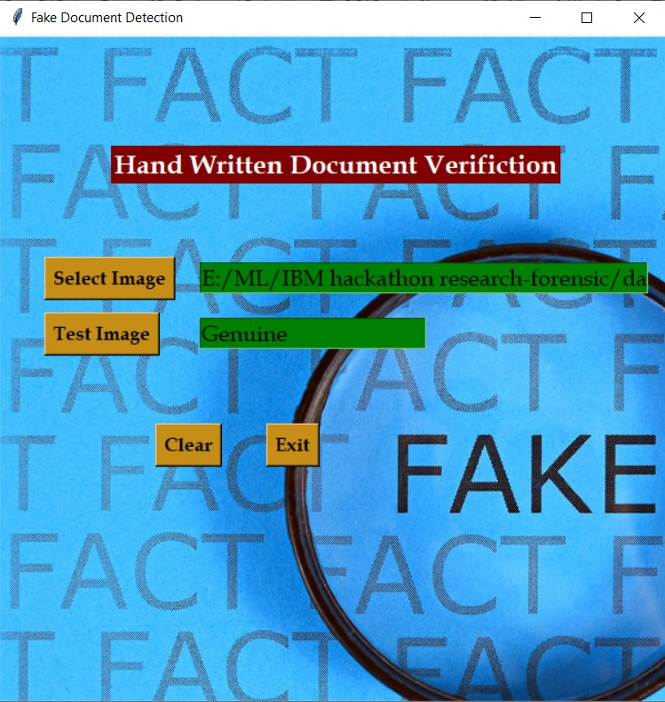
Fig. 9. Tested Document as Genuine
Fig. 10. Tested Document as Fake
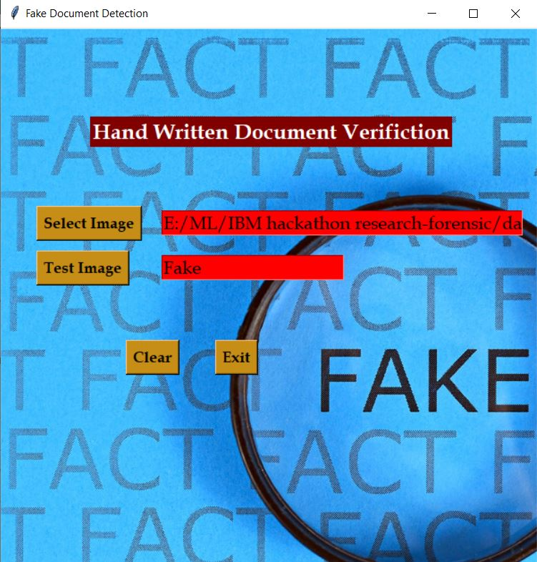
Finally, we have successfully implemented the CNN models i.e. ResNet15 and VGGNet16 by using Secure Multi-Party Computation in securing the documents. We got various accuracies for different number of epochs, where for 100 epochs we got highest accuracy in ResNet50. As the accuracy of VGGNet16 at 100 epochs not reached the heights when compared to our ResNet50 model and other approaches, we considered the ResNet50 model for evaluation. Although, we have received somewhat higher accuracy in VGGNet16 using SMPC, we have compared our accuracies with the existing approaches. The table of comparison of accuracies is depicted in Table.III below.
- Comparison of Accuracies
Approach | Accuracy
LPQ [7] | 89.54%
SEG-WI [25] | 97.27%
Conjugate approach [26] | 97.50%
Ours (VGGNet16 with SMPC) | 93.88%
Ours (ResNet50 with SMPC) | 97.62%

Conclusion
This paper proposes Forensic Verification of Handwriting Documents using CNN models with the help of Secure Multi-Party Computation to secure the documents. In todays’ world, we need to strive a lot for securing the data. There is high competition and insecurity for valuable data or important documents. Especially, handwritten documents can be duplicated or fabricated, therefore, we need to test the integrity of the document. By using the CNN models, we got high accuracy rate. In addition, we need to secure the documents that are used for training and testing. So, we used cryptographic protocols to secure the document. The Secure Multi-Party Computation fits for our problem in preserving the privacy of each authors’ documents. Machine learning and Image processing techniques help us identify the document efficiently and in a very short time.

References

- International Forensic Sciences (IFS)
IFS: Court Appointed Commission, Govt. of India Certified, Govt. of Maharashtra Regd., Govt. of India Recognized startup & ISO Certified. https://www.forensic.co.in/handwriting_document_signature_examination-2/
- Pinhelli, Fabio, A. Britto, Luiz Oliveira, Yandre M. G. Costa and Diego Bertolini. “Single-sample writers - "Document Filter" and their impacts on writer identification.” ArXiv abs/2005.08424 (2020): n. pag.
- Muhammad Rashid Hussain, Ahsen Raza, Imran Siddiqi, Khurram Khurshid, Chawki Djeddi, A comprehensive survey of handwritten document benchmarks: structure, usage and evaluation, EURASIP Journal on Image and Video Processing (2015) 2015:46, DOI 10.1186/s13640-015-0102-5
- C.M. Deviterne-Lapeyre, Interpol review of questioned documents 2016e2019, Forensic Science International: Synergy, https://doi.org/10.1016/j.fsisyn.2020.01.012
- Bensefia, A., Paquet, T. Writer verification based on a single handwriting word samples. J Image Video Proc. 2016, 34 (2016). https://doi.org/10.1186/s13640-016-0139-0
- Jayaram Kinthali, Kowshik Kotha, Kanithi Santosh Kumar, Jagilinki Jayalaxmi, Handwritten Text Recognition using Deep Learning with TensorFlow, International Journal of Engineering and Technical Research V9(05), May 2020, DOI: 10.17577/IJERTV9IS050534
- Yaacoub Hannad, Imran Siddiqi, Mohamed El Youssfi El Kettani, Writer identification using texture descriptors of handwritten fragments, Expert Systems with Applications, Volume 47, 1 April 2016, Pages 14-22. https://doi.org/10.1016/j.eswa.2015.11.002
- Subramanian R.R., Seshadri K. (2019) Design and Evaluation of a Hybrid Hierarchical Feature Tree Based Authorship Inference Technique. In: Kolhe M., Trivedi M., Tiwari S., Singh V. (eds) Advances in Data and Information Sciences. Lecture Notes in Networks and Systems, vol 39. Springer, Singapore. https://doi.org/10.1007/978-981-13-0277-0_8
- R. R. Subramanian, B. R. Babu, K. Mamta and K. Manogna, "Design and Evaluation of a Hybrid Feature Descriptor based Handwritten Character Inference Technique," 2019 IEEE International Conference on Intelligent Techniques in Control, Optimization and Signal Processing (INCOS), 2019, pp. 1-5, doi: 10.1109/INCOS45849.2019.8951393.
- R. R. Subramanian and R. Ramar, "Design of Offline and Online Writer Inference Technique", International Journal of Innovative Technology and Exploring Engineering, vol. 9, no. 2S2, Dec. 2019, ISSN 2278-3075.
- R Raja Subramanian, R Nikhil Mourya, V Prudhvi Teja Reddy, B Narendra Reddy, Srikar Amara, “Lung Cancer Prediction Using Deep Learning Framework”, International Journal of Control and Automation, vol. 13, no. 3, pp. 154-160, 2020.
- R. R. Subramanian, D. Achuth, P. S. Kumar, K. Naveen kumar Reddy, S. Amara and A. S. Chowdary, "Skin cancer classification using Convolutional neural networks," 2021 11th International Conference on Cloud Computing, Data Science & Engineering (Confluence), 2021, pp. 13-19, doi: 10.1109/Confluence51648.2021.9377155.
- R. R. Subramanian, C. S. Niharika, D. U. Rani, P. Pavani and K. P. L. Syamala, "Design and Evaluation of a Deep Learning Algorithm for Emotion Recognition," 2021 5th International Conference on Intelligent Computing and Control Systems (ICICCS), 2021, pp. 984-988, doi: 10.1109/ICICCS51141.2021.9432336.
- R. Raja Subramanian, V. Vasudevan, A deep genetic algorithm for human activity recognition leveraging fog computing frameworks, Journal of Visual Communication and Image Representation, Volume 77, 2021, 103132
- Raja Subramanian R., Vasudevan V. (2021) HARfog: An Ensemble Deep Learning Model for Activity Recognition Leveraging IoT and Fog Architectures. In: Gunjan V.K., Zurada J.M. (eds) Modern Approaches in Machine Learning and Cognitive Science: A Walkthrough. Studies in Computational Intelligence, vol 956. Springer, Cham.
- R. Raja Subramanian, H. Mohan, A. Mounika Jenny, D. Sreshta, M. Lakshmi Prasanna and P. Mohan, "PSO Based Fuzzy-Genetic Optimization Technique for Face Recognition," 2021 11th International Conference on Cloud Computing, Data Science & Engineering (Confluence), 2021, pp. 374-379, doi: 10.1109/Confluence51648.2021.9377028.
- S. Alagarsamy, R. Raja Subramanian, T. Shree, S. kannan, M. Balasubramanian and V. Govindaraj, "Prediction of Lung Cancer using Meta-Heuristic based Optimization Technique: Crow Search Technique," 2021 International Conference on Computing, Communication, and Intelligent Systems (ICCCIS), 2021, pp. 186-191, doi: 10.1109/ICCCIS51004.2021.9397199.
- IAM Handwriting Database https://fki.tic.heia-fr.ch/databases/iam-handwriting-database
- Sundari S and Ananthi M, "Secure multi-party computation in differential private data with Data Integrity Protection," 2015 International Conference on Computing and Communications Technologies (ICCCT), 2015, pp. 180-184, doi: 10.1109/ICCCT2.2015.7292742.
- Zhou, Jiapeng, Yuxiang Feng, Zhenyu Wang, and Danyi Guo. 2021. "Using Secure Multi-Party Computation to Protect Privacy on a Permissioned Blockchain" Sensors 21, no. 4: 1540. https://doi.org/10.3390/s21041540
- Anh-Tu Tran, The-Dung Luong, Jessada Karnjana, Van-Nam Huynh, An efficient approach for privacy preserving decentralized deep learning models based on secure multi-party computation, Neurocomputing, Volume 422, 2021, Pages 245-262, ISSN 0925-2312, https://doi.org/10.1016/j.neucom.2020.10.014.
- Simonyan, K. and Andrew Zisserman. “Very Deep Convolutional Networks for Large-Scale Image Recognition.” CoRR abs/1409.1556 (2015): n. pag.
- K. He, X. Zhang, S. Ren and J. Sun, "Deep Residual Learning for Image Recognition," 2016 IEEE Conference on Computer Vision and Pattern Recognition (CVPR), 2016, pp. 770-778, doi: 10.1109/CVPR.2016.90.
- Srikanth Tammina (2019); Transfer learning using VGG-16 with Deep Convolutional Neural Network for Classifying Images; International Journal of Scientific and Research Publications (IJSRP) 9(10) (ISSN: 2250-3153), DOI: http://dx.doi.org/10.29322/IJSRP.9.10.2019.p9420
- Parveen Kumar, Ambalika Sharma, Segmentation-free writer identification based on convolutional neural network, Computers & Electrical Engineering, Volume 85, 2020, 106707, ISSN 0045-7906, https://doi.org/10.1016/j.compeleceng.2020.106707.
- Malihe Javidi, Mahdi Jampour, A deep learning framework for text-independent writer identification, Engineering Applications of Artificial Intelligence, Volume 95, 2020, 103912, ISSN 0952-1976, https://doi.org/10.1016/j.engappai.2020.103912.

